BIOE5810

**Final Report**

Alex Rivas

Parth Patel

**PURPOSE**

Fibromyalgia is a condition that can be characterized by widespread pain, fatigue, depressive mental health, and worsened quality of life, disturbed sleep, and tender points located in pairs throughout the body [1]. The painful that Fibromyalgia patients experience is not accompanied by inflammation of the affected tissue, and therefore said patients do not experience tissue damage or deformity despite potentially disabling body pain [2]. Fibromyalgia is the second most common rheumatoid disorder after osteoarthritis and affects about 8% of the population at a 2:1 female to male ratio [3]. Despite this prominence, the cause of fibromyalgia is unknown and it is difficult to diagnose. In 2010, the American College of Rheumatology outlined 3 criteria to help diagnose Fibromyalgia [4]:

* Widespread pain index (WPI) ≥ 7 and Symptom Severity Scale (SS) ≥ 5 OR WPI 3–6 and SS ≥ 9
* Symptoms have been present at a similar level for at least three months
* No other diagnosable disorder otherwise explains the pain.

Despite this criteria, there exist no laboratory tests or imaging technique that can confirm and differentiate fibromyalgia patients from healthy adults [5]. Therefore, there is a clearly defined need for an objective biomarker as a tool to help doctors form a diagnosis.

Fibromyalgia patients demonstrate a suppressed autonomic nervous system function (ANS) [7, 8]. Since Heart Rate Variability is a reflection of overall ANS function, one study found HRV to be a useful biomarker for the abnormal sympathovagal balance in fibromyalgia patients [6]. Furthermore, an assessment of HRV parameters in fibromyalgia found **SDNN/RMSSD** to be a valuable time domain HRV parameter to quantify subjective symptoms in fibromyalgia patients [9].

The **scope** of this project is to create an HRV monitor that can help doctors better diagnose Fibromyalgia in patients. Given that 24-hour recording times are regarded as the gold standard for clinical HRV assessment, the idea is to create an ambulatory HRV monitor that patients will use over the course of 24-hours, from which the device will analyze SDNN/RMSSD as the parameter for HRV [10].

**SYSTEM DESCRIPTION**

**ECG signal acquisition:** We have used AD8232 heart monitor sensor along with Arduino Mega a microcontroller.

**AD8232**

Description:

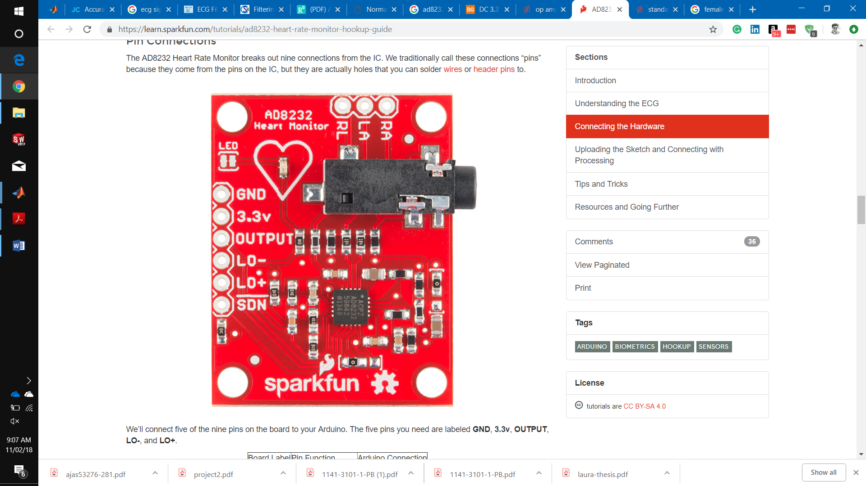

*AD8232 sensor*

AD8232 is a heart monitor sensor detects heart beats. Overall, in AD8232 **Instrumentation amplifiers** are used to amplify signals coming from part of body. Also, AD8232 has **differential amplifier** inside. Diff. Amp. subtracts the signals coming from inputs therefore it is very good at eliminating noise. Then the signal is processed by filters that we have described later in this section. Output signal acquisition is made by Arduino Mega microcontroller and processed further.

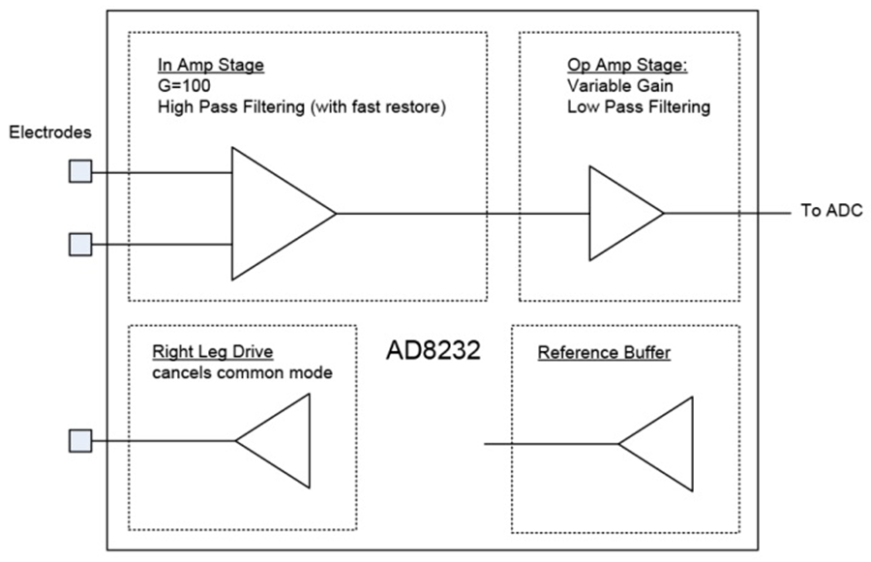

*Figure: simplified circuit diagram of the AD8232*

Here in AD8232, 10MΩ resistors are used before electrodes to prevent body from electrical shock where current flow never exceeds 10 μA.

**Analog Amplifying in AD8232:**

Gain= 100

The key function in the signal chain is the instrumentation amplifier. The electrodes from the body are connected directly into the high impedance input nodes of this amplifier, which features an input impedance of 100 mΩ. A fixed gain of 100 V/V is integrated in this stage to amplify the small signals that are applied to the input. The second stage consists of an operational amplifier.

The operational amplifier can be configured as a 2-pole low-pass filter to remove line noise and other interference. The output signal represents a clean, amplified version of the ECG signal as provided at the input of the AD8232. [11]

**Analog Filtering in AD8232:**

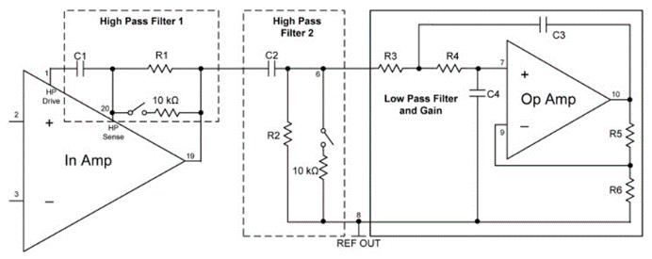

To obtain ECG waveform with the minimum distortion, AD8232 is configured with a 0.5 Hz dual pole high-pass filter, and followed a double pole, 40 Hz, low-pass filter to eliminate additional noise.

The signals obtained from the body are weak and noisy, making them sensitive to motion related artifacts. For this reason, filtering is important to get a useful signal. The input amplifier provides gain and high-pass filtering simultaneously. It adds a gain of 100 V/V to the small ECG signals, while rejecting the electrode offsets, which can be as high as ±300 mV.

Which research paper shows ECG signal frequency is between 5 to 26 Hz which make you to choose this sensor of specified frequency?

The next filter stage supports a second-order low-pass filter, using a Sallen Key configuration. This filter is important to remove motion artifacts and correct the base line. The suggested cutoff frequency is around 25 Hz. The output of this amplifier stage is able to swing within 100 mV from +VS and ground, so nearly the entire dynamic range of the ADC following the AD8232 can be used, maximizing the system resolution if the ADC and the AD8232 are powered from the same supply voltage. [13]

**High pass filter**: fc = 100 / (2p R9 C6); where R9= 10kOHM(check) and C1 = 0.22µF(check) place the pole of the first high-pass at 7Hz. <https://www.researchgate.net/publication/257300158_Programmable_Gain_Amplifiers_with_DC_Suppression_and_Low_Output_Offset_for_Bioelectric_Sensors> to describe from where the gain 100 comes in the equation

two-pole high pass filter for eliminating motion artifacts

**Low pass filter**: fc = 1 / [2*pi* sqrt(R18 C14 R17 C7)]

Gain = 1 + R12/R13; that is how the evaluation board components place the cutoff frequency for the low-pass filter at approximately 25Hz and the gain to 11. Keep the sum of R12 and R13 above 50kOHM to save power and to avoid excessive loading of the output. Moreover, the components R14, C13, R19 and C15 offer additional Low pass filtering options.

Consider <https://wiki.analog.com/_detail/resources/eval/ad8232_char_z_sch_horiz.jpg?id=resources%3Aeval%3Aad8232-evaluation-guide%3Aa03321a> for figure. [12]

**Board connection**: AD8232 Heart Rate Sensor to Arduino. To make it easy, we used female male header strip in between.

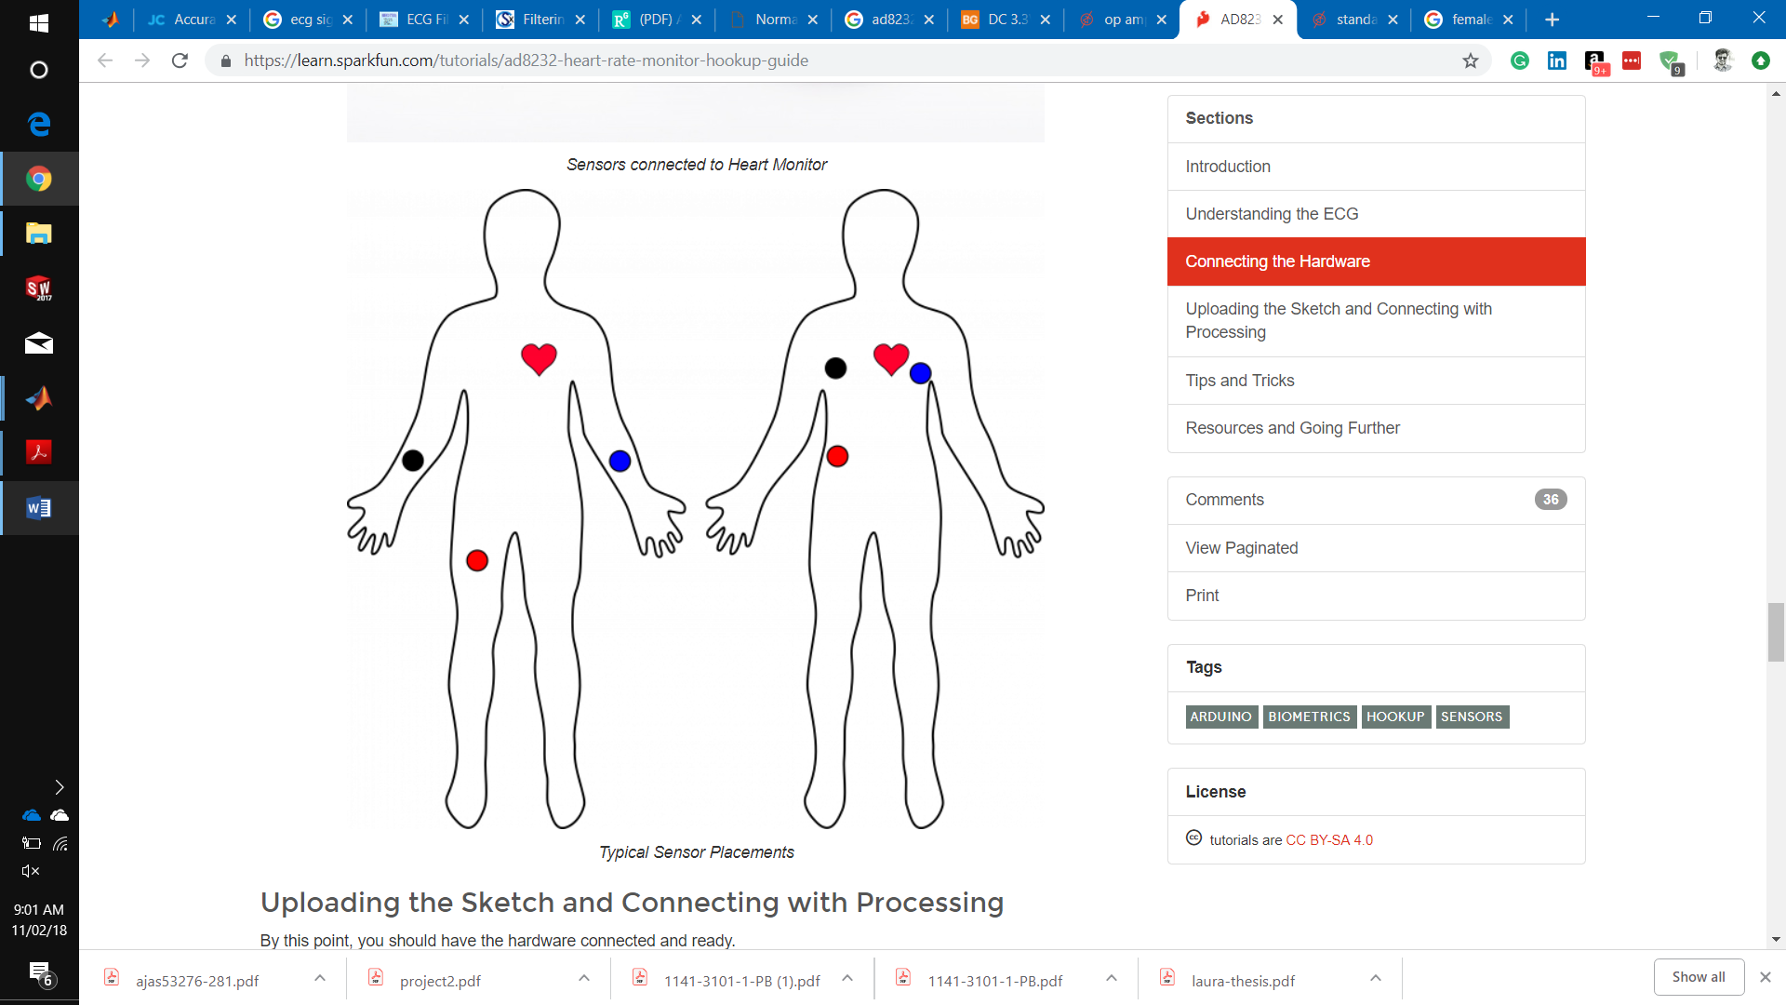

3 leads placement on body

**AD8232 Label Pin Function Arduino Connection**

GND Ground GND

3.3v 3.3v Power Supply 3.3v

OUTPUT Output Signal A0

LO- Leads-off Detect - 11

LO+ Leads-off Detect + 10

SDN Shutdown Not used

**Block Diagram:**

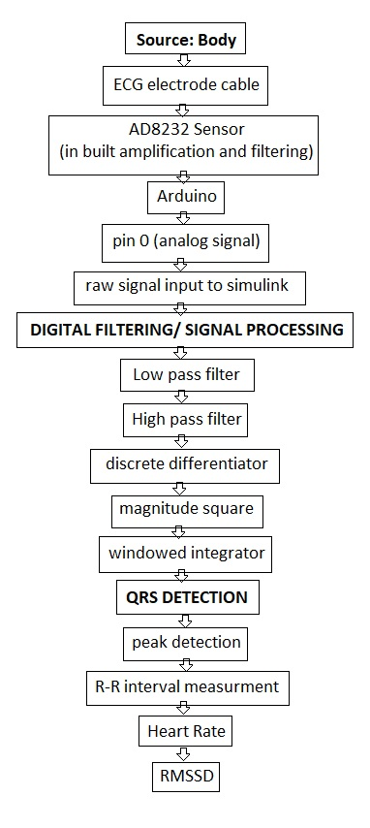

We have recorded our own ECG signal by using Simulink signal analyzer and stored those data in Matlab to be proceed further. We used 250 Hz sampling rate.

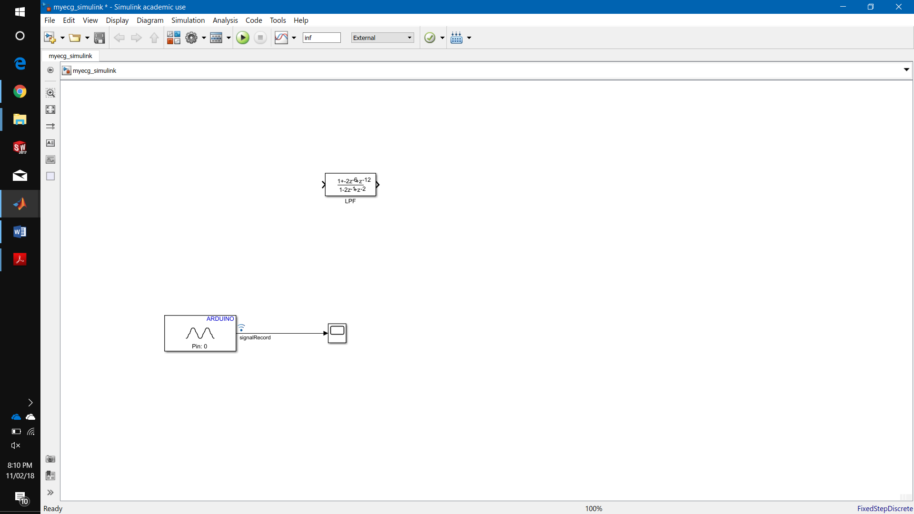

We have in built amplifier, so we didn’t put amplifier between this recording. Our original signal does look like this.

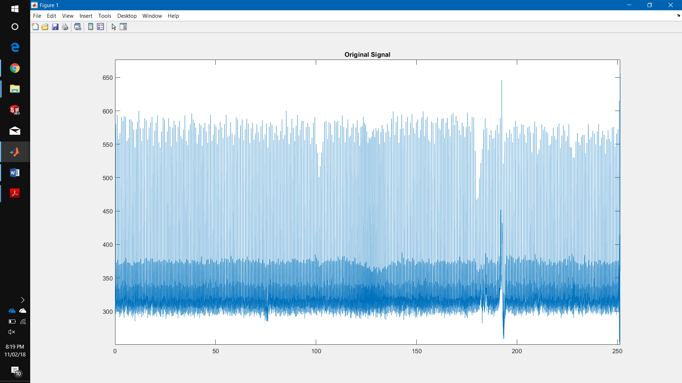 Gain= 100

Zooming in gives

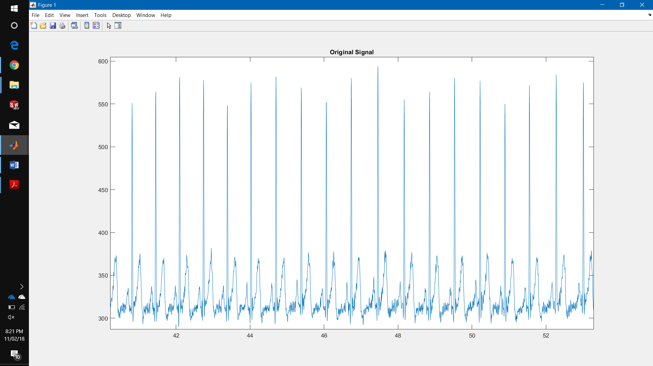

Once this signal comes to matlab, we can process these data. For example, we can make a digital filter by design tools for this signal and/or we can do HRV analysis. For our signals, we do not need a digital filter as AD8232 has both low pass and high pass filter as discussed above. However, we have made notch filter to eliminate 60 Hz powerline noise and filter to remove some noise like loose connection. It also helps to have less (no) error for peak detection.

The various kind of noises that are present in the ECG signal are broadly classified into the following types

Power line interference (50Hz/60Hz)   
Base line wander (0.5 Hz) muscle noise (8Hz to 14Hz)   
Internal amplifiers noise   
Electrosurgical noise   
Electrode contact noise   
Polarization noise etc.

The next step is QRS complex and peak detection.

**…………………………………………………………………………….**

**Front End and Amplification:** We will use a body as an ECG signal source. This can be measured by ECG electrode cable that is connected to Arduino on power panel. At pin 0 we have an analog output from Arduino. This unprocessed output can be seen in Scope in Simulink model. The raw ECG signal then goes to a digital amplifier gain in Simulink.

**Signal Processing**: the purpose of this stage is to clean the raw signal (measured signal) as it might have noises resulting from power supply frequency, breathing muscle artifacts, instrument movement or patient movement. This will be cleaned by filters. A low pass filter is used to remove high frequency noise such as that from the ECG instrument. A high pass filter is used to remove the low noise frequencies coming from respiration as the base line drift noise. Band reject filters (Notch filter) can be used to remove power line noise.

**Beat Detection/HRV Analysis**: A differentiator is used on the filtered signal to detect peaks. The signal is differentiated, squared, and integrated to isolate the peaks. From here, a real-time peak detection software can be used on the isolated peaks for HRV analysis. While we currently have functional code that goes through the whole process from start to finish, outputting an HRV value on an inputted ECG signal, this only works on recorded data.

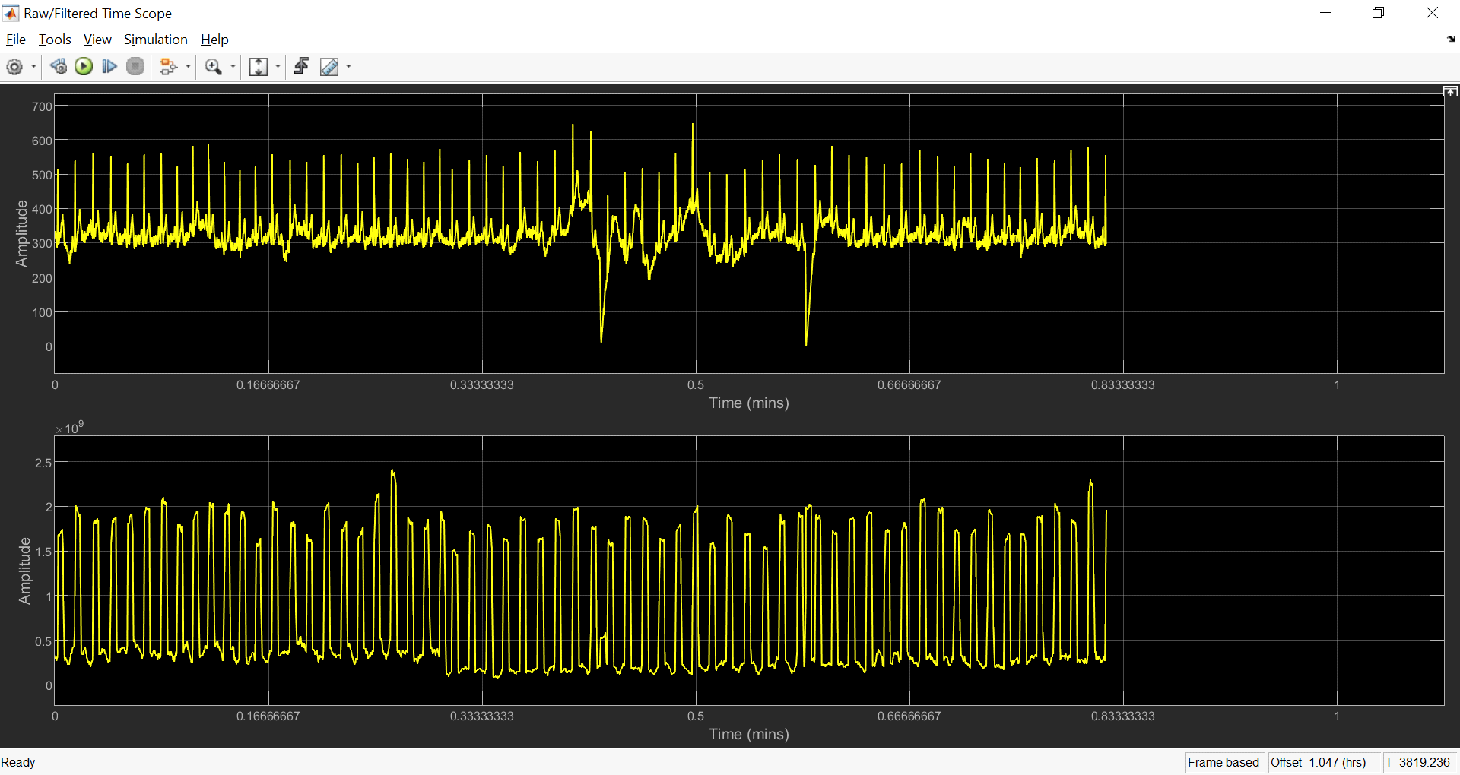

Raw ECG and integrated waveform, examined in real time

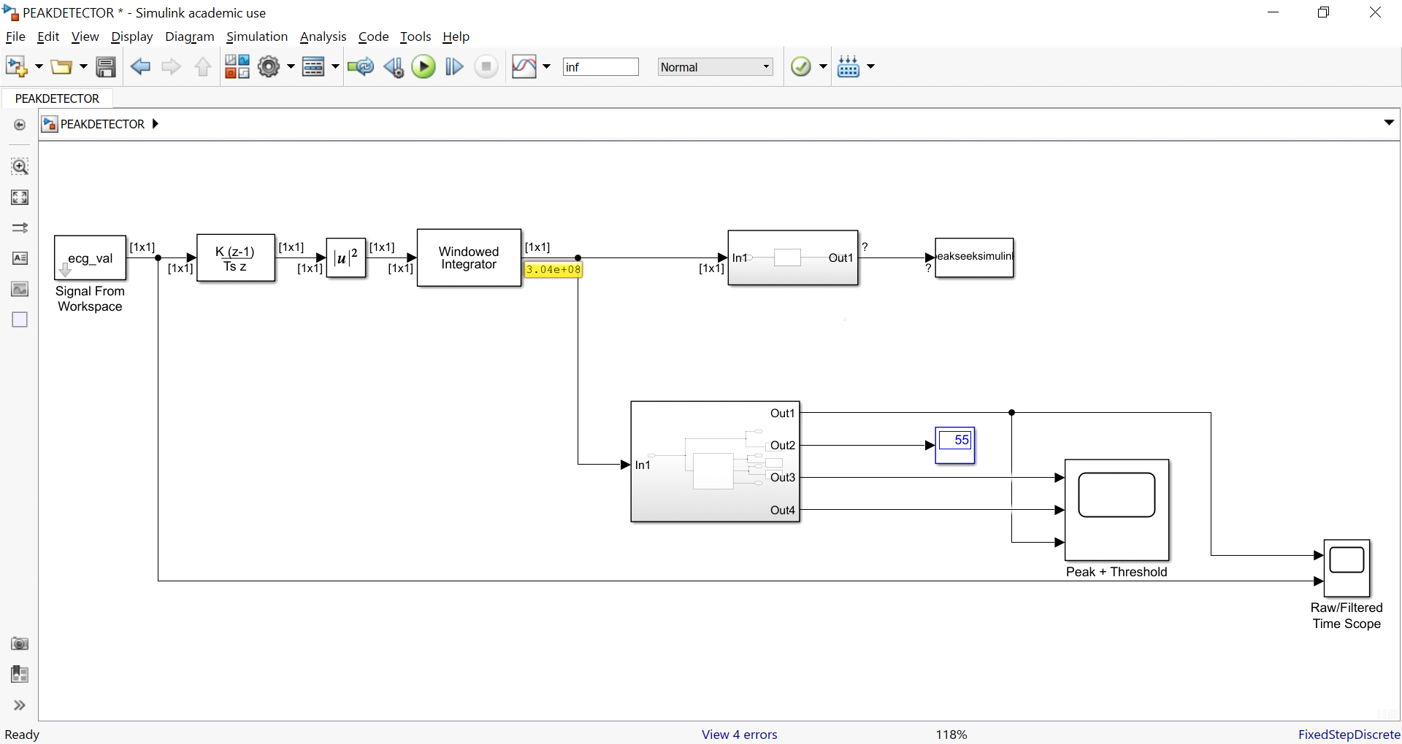

Simulink Model, currently not yet fully refined for real-time signal processing

**REQUIREMENTS**

All components will be examined for FDA requirements.

IEC 60601-2-47 requirements for AD8232 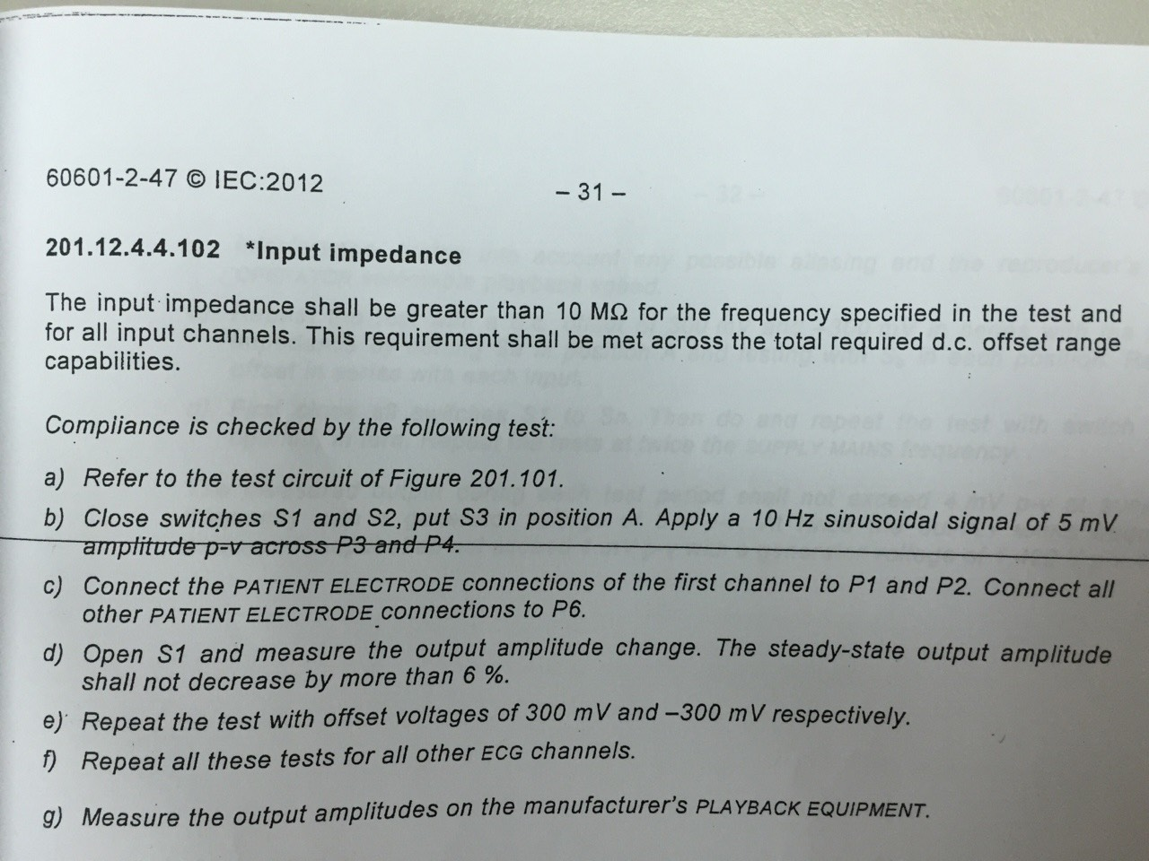

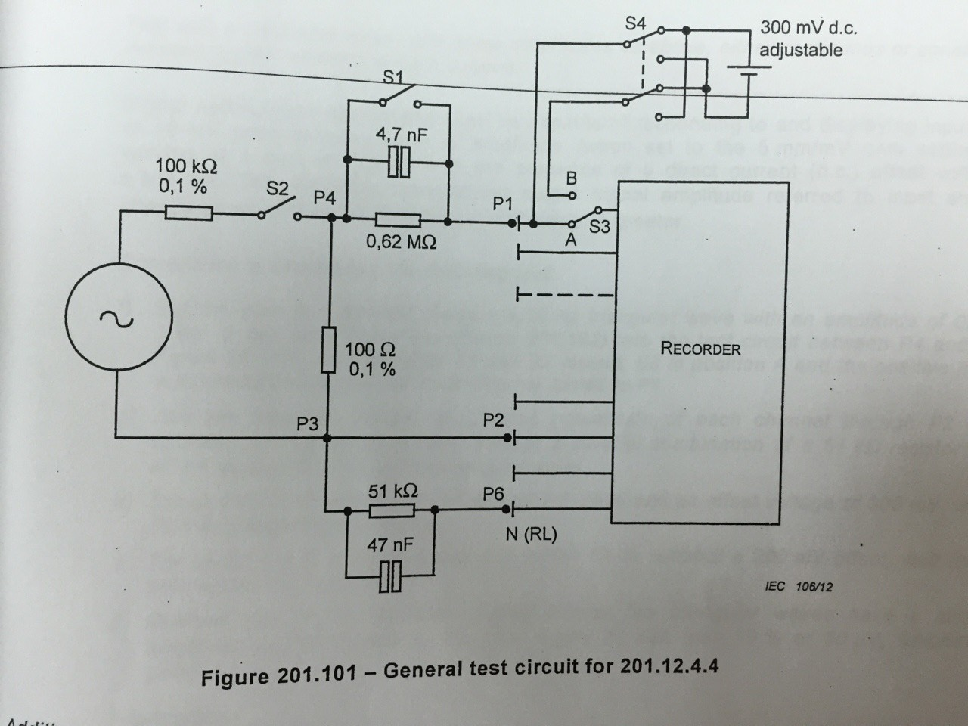

*Test circuit*

**VERIFICATION**

We will use PhysioNet waveform of healthy ECG controls to test the functionality of our monitor, as well as using real ECG recordings from ourselves to test the ECG connection. We can measure ECG signal using our sensor and analyze the data at the Simulink level. The analysis goes through the entire block diagram and output an SDNN/ RMSSD value. The code has been developed for real-time data processing.

**VALIDATION**

We will generate a fibromyalgia waveform based on the data presented by Kang et al. [9] in finding SDNN/RMSSD as a valid time domain parameter for HRV in Fibromyalgia patients. We can compare the HRV measurements from the healthy control data in PhysioNet to the generated fibromyalgia waveform to see if there is a statistical difference. According to the study, there was an observed SDNN/RMSSD value of 1.68 ± 0.46 ms. This will be the measurement that we will use to test for fibroymalgia in an ECG signal. Since we don't have raw ECG data for this, we will have to generate a waveform that replicates the above specified quantity. (needs to be changed)

**RESPONSIBILITIES**

Parth: Assembling front end, filtering, testing

Alex: QRS Detection, R-R Interval measurement, HRV analysis

**SCHEDULE**

Our original schedule allocated for a small "safety" net of time after the 8 total weeks to finish the necessary objectives for the project. At the moment, we have a functional front end and different filtering methods for the raw ECG signal. The filtering still needs to be refined, though there has been a lot of progress on this end.

As for analyzing the software, there is a Simulink Model available for a beat detector that is fully functional. There is also fully functional code that analyzes SDNN/RMSSD for a recorded ECG file. At the moment we are able to record an ECG signal and fully process the file to produce an HRV output although it does not work in real time. We are able to plot the raw ECG, filtered ECG, and Beat Detector outputs via Simulink in real time. We are also have real time values for the time of each peak, though we are not able to process the data yet. The main obstacle here is figuring out how to calculate the HRV parameters in real time given that they require looking at values from the whole data set. As such, the code for examining a pre-recorded ECG file is very straightforward, but it becomes much more complicated trying to do it in real time.

I believe 1 week is necessary to fully adjust the Simulink model for real-time data. From there, we can generate waveforms that replicate a Fibromyalgia waveform and observe if the HRV monitor can detect a presence of Fibromyalgia given the aforementioned observed SDNN/RMSSD.

**Recommendations for Future Work**

This project was successful in completing its primary objectives. This project has much room for improvement, and if a new group were interested in taking it further, this project group has several suggestions:

**Battery Powered -** According to the design, the system currently only works using a Laptop USB port powered. The next suggestion explores one way to reduce power consumption.

**Integrate more components onto single PCB -** Integrating device components including the DSP on the same board may allow for increased accuracy and speed of the device.

**Add new algorithms to detect arrhythmias -** This would increase the scope of the device and make it more marketable in the future.

**Work with smart phones and smart watches**

**Make it to know irregularities in ecg signal for the purpose of diagnose**

**REFERENCES**

1. Bennett, R. M., Jones, J., Turk, D. C., Russell, I. J. & Matallana, L. An internet survey of 2,596 people with fibromyalgia. *BMC Musculoskeletal Disorders* **8,** (2007).
2. Jahan, F., Nanji, K., Qidwai, W. & Qasim, R. Fibromyalgia Syndrome: An Overview of Pathophysiology, Diagnosis and Management. *Oman Medical Journal* **27,** 192–195 (2012).
3. Wolfe, F., Ross, K., Anderson, J., Russell, I. J. & Hebert, L. The prevalence and characteristics of fibromyalgia in the general population. *Arthritis & Rheumatism* **38,** 19–28 (1995).
4. Wolfe, F. *et al.* The American College of Rheumatology Preliminary Diagnostic Criteria for Fibromyalgia and Measurement of Symptom Severity. *Arthritis Care & Research* **62,** 600–610 (2010).
5. Lerma, C. *et al.* Nocturnal heart rate variability parameters as potential fibromyalgia biomarker: correlation with symptoms severity. *Arthritis Research & Therapy* **13,** (2011).
6. Staud, R. Heart rate variability as a biomarker of fibromyalgia syndrome. *Future Rheumatology* **3,** 475–483 (2008).
7. Silver DS, Markoff SR, Naghi L, et al. Reduction in Parasympathetic Autonomic Nervous System Function in Fibromyalgia Patients. Arch Med. 2016, 8:2.
8. Meeus M. et al. Heart rate variability in patients with fibromyalgia and patients with chronic fatigue syndrome: a systematic review. Semin Arthritis Rheum. 2013 Oct; 43(2): 279–287. Published online 2013 Jul 6. doi: 10.1016/j.semarthrit.2013.03.004
9. Kang JH, Kim JK, Hong SH, Lee CH, Choi BY. Heart rate variability for quantification of autonomic dysfunction in fibromyalgia. Ann Rehabil Med. 2016;40(2):301–309.
10. Shaffer F, Ginsberg JP. An Overview of Heart Rate Variability Metrics and Norms. *Frontiers in Public Health*. 2017;5:258. doi:10.3389/fpubh.2017.00258.
11. <https://www.analog.com/en/products/ad8232.html>
12. <https://wiki.analog.com/resources/eval/ad8232-evaluation-guide/a03321a>
13. <https://www.analog.com/en/technical-articles/predicting-and-finding-your-limits.html>]

Appendix

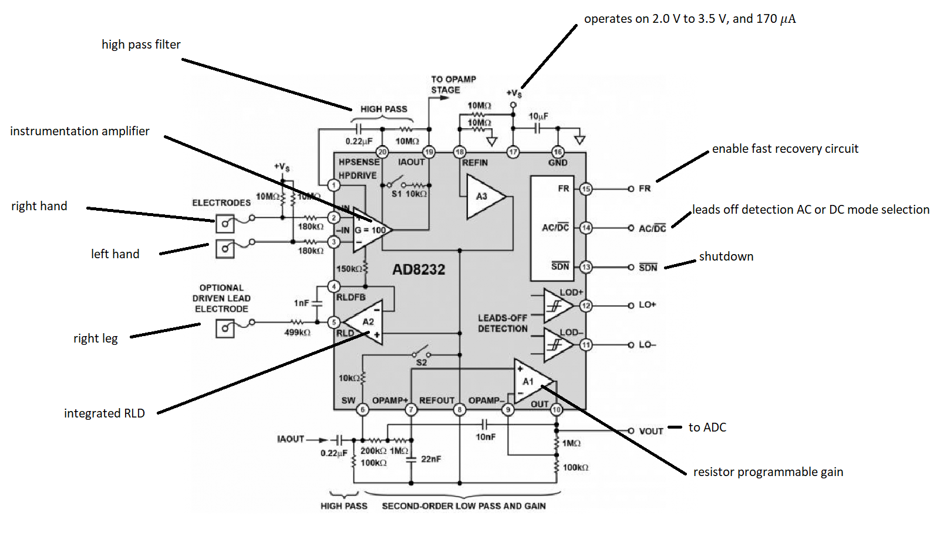

*Figure: circuit diagram of AD8232*